**Practical No. 3**

1. **Working with Different UI Widgets**
2. **Designing UI**

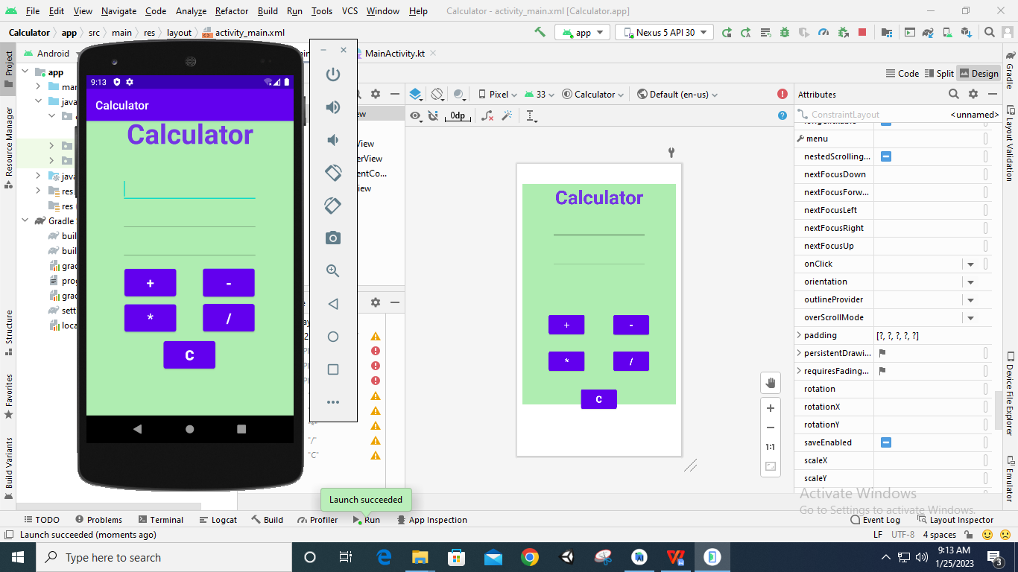

1. **Code**

**package** com.example.calculator  
  
**import** androidx.appcompat.app.AppCompatActivity  
**import** android.os.Bundle  
**import** android.widget.Button  
**import** android.widget.EditText  
**import** android.widget.Toast  
  
**class** MainActivity : AppCompatActivity() {  
 **override fun** onCreate(savedInstanceState: Bundle?) {  
 **super**.onCreate(savedInstanceState)  
 setContentView(R.layout.*activity_main*)  
  
 **var** text1:EditText=findViewById(R.id.*text11*)  
 **var** text2:EditText=findViewById(R.id.*text12*)  
 **var** text3:EditText=findViewById(R.id.*text13*)  
  
 **var** btn1: Button =findViewById(R.id.*button1*)  
 btn1.setOnClickListener()**{  
 var** num1=Integer.parseInt(text1.*text*.toString())  
 **var** num2=Integer.parseInt(text2.*text*.toString())  
  
 **var** sum=num1+num2  
 text3.setText(**""**+sum)  
 Toast.makeText(*applicationContext*,**"Addition is "**+sum,Toast.*LENGTH_LONG*).show()  
 **}  
  
 var** btn2: Button =findViewById(R.id.*button2*)  
 btn2.setOnClickListener()**{  
 var** num1=Integer.parseInt(text1.*text*.toString())  
 **var** num2=Integer.parseInt(text2.*text*.toString())  
  
 **var** sum=num1-num2  
 text3.setText(**""**+sum)  
 Toast.makeText(*applicationContext*,**"Subtraction is "**+sum,Toast.*LENGTH_LONG*).show()  
 **}  
  
 var** btn3: Button =findViewById(R.id.*button3*)  
 btn3.setOnClickListener()**{  
 var** num1=Integer.parseInt(text1.*text*.toString())  
 **var** num2=Integer.parseInt(text2.*text*.toString())  
  
 **var** sum=num1*num2  
 text3.setText(**""**+sum)  
 Toast.makeText(*applicationContext*,**"Multiplication is "**+sum,Toast.*LENGTH_LONG*).show()  
 **}  
  
 var** btn4: Button =findViewById(R.id.*button4*)  
 btn4.setOnClickListener()**{  
 var** num1=Integer.parseInt(text1.*text*.toString())  
 **var** num2=Integer.parseInt(text2.*text*.toString())  
  
 **var** sum=num1/num2  
 text3.setText(**""**+sum)  
 Toast.makeText(*applicationContext*,**"Division is "**+sum,Toast.*LENGTH_LONG*).show()  
 **}  
 var** btn5: Button =findViewById(R.id.*button5*)  
 btn5.setOnClickListener()**{** text1.setText(**""**)  
 text2.setText(**""**)  
 text3.setText(**""**)  
 **}** }  
}

1. **Output:**

**Addition**

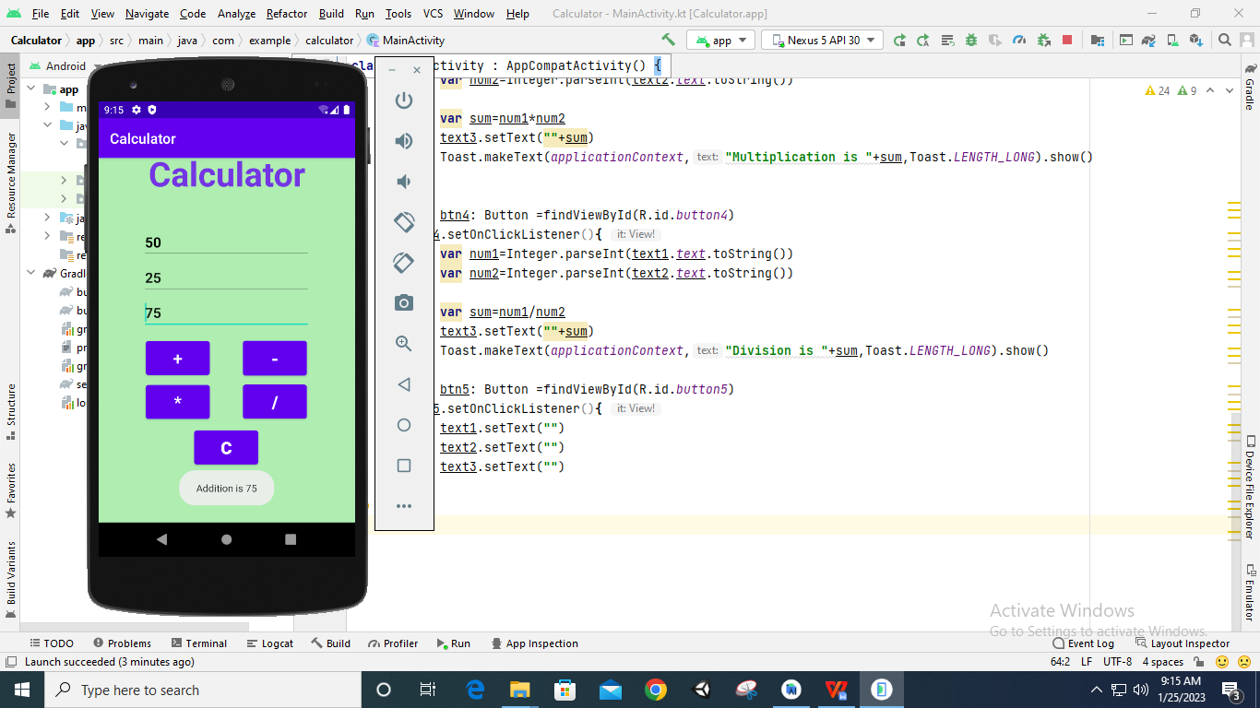

**Subtraction**

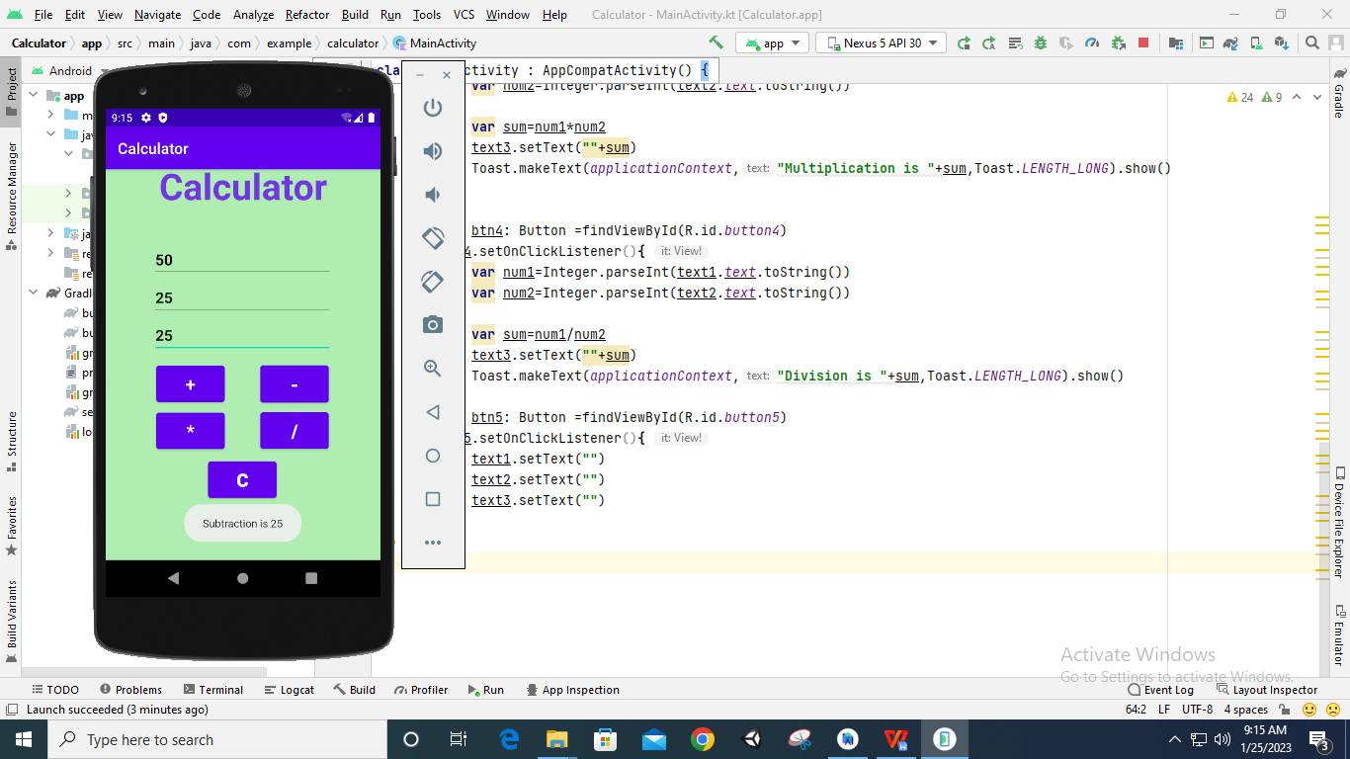

**Multiplication**

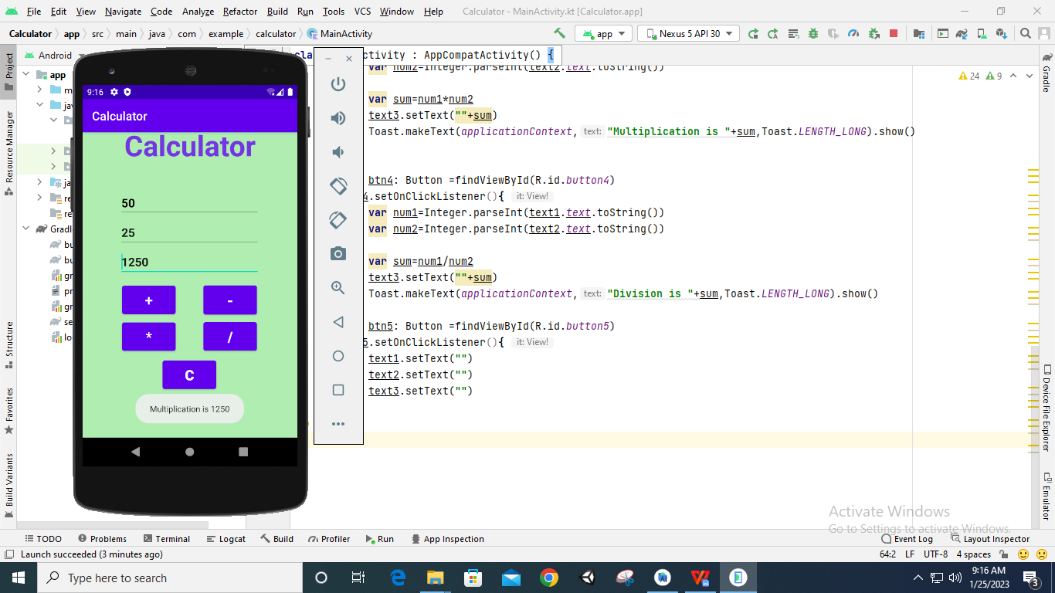

**Division**

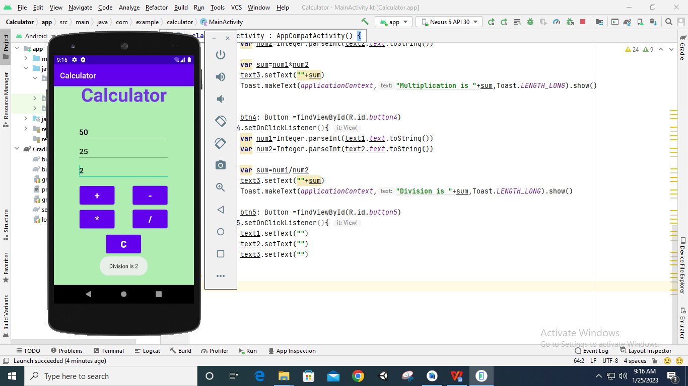

**Clear Button**

